TOPIC 4 : DYNAMIC PROGRAMMING
NAME: LAKSHMI DEVI.J
REG.NO: 192524300

1. You are given the number of sides on a die (num_sides), the number of dice to throw (num_dice), and a target sum (target). Develop a program that utilizes dynamic programming to solve the Dice Throw Problem.
Aim
To find the number of ways to obtain a target sum using a given number of dice and sides using Dynamic Programming.
Pseudo Code
- Create dp[dice][sum].
- Set dp[0][0] = 1.
- For every dice:
  - For every possible sum:
    - Try every face from 1 to num_sides.
    - Add the previous number of ways.
- Return dp[num_dice][target].
Python Program
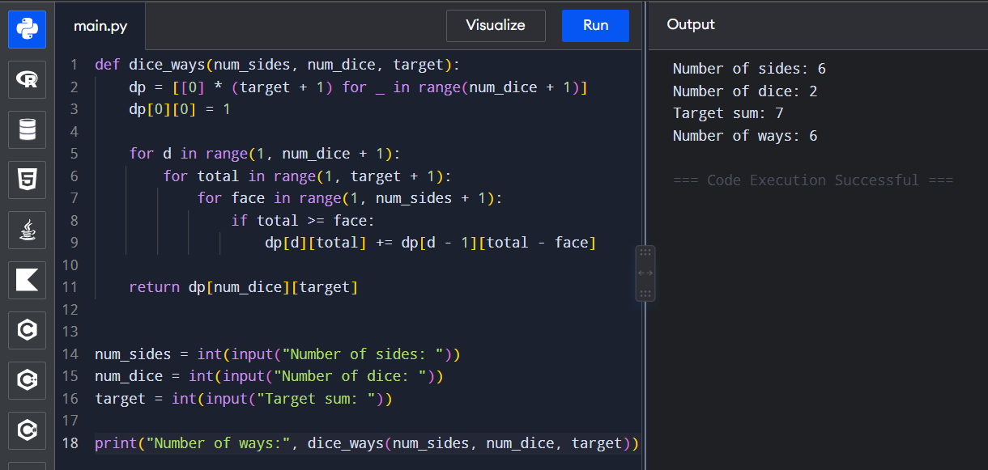
Time Complexity: O(n³)
Space Complexity: O(n²)

2. In a factory, there are two assembly lines, each with n stations. Each station performs a specific task and takes a certain amount of time to complete. The task must go through each station in order, and there is also a transfer time for switching from one line to another. Given the time taken at each station on both lines and the transfer time between the lines, the goal is to find the minimum time required to process a product from start to end.
Aim
To find the minimum time required to process a product through two assembly lines using Dynamic Programming.
Pseudo Code
- Initialize the time for the first station on both lines.
- For every next station:
  - Calculate the minimum time to reach line 1.
  - Calculate the minimum time to reach line 2.
- Add the exit times.
- Return the smaller value.

Python Program
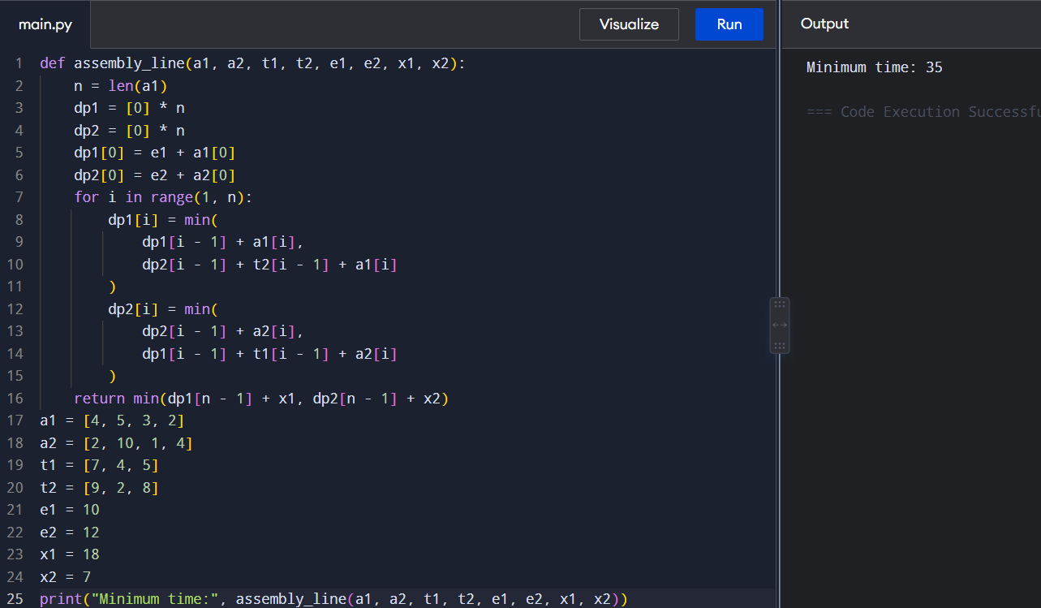
Time Complexity: O(n)
Space Complexity: O(n)

3. An automotive company has three assembly lines (Line 1, Line 2, Line 3) to produce different car models. Each line has a series of stations, and each station takes a certain amount of time to complete its task. Additionally, there are transfer times between lines, and certain dependencies must be respected due to the sequential nature of some tasks. Your goal is to minimize the total production time by determining the optimal scheduling of tasks across these lines, considering the transfer times and dependencies.
Aim
To find the minimum production time when a product can move among three assembly lines while respecting the given sequential dependencies.
Pseudo Code
- Initialize the time at the first station of each line.
- For every station:
  - Stay on the same line.
  - Or transfer from either of the other two lines.
- Choose the minimum time.
- Continue until the final station.
- Return the minimum final time.
Python Program
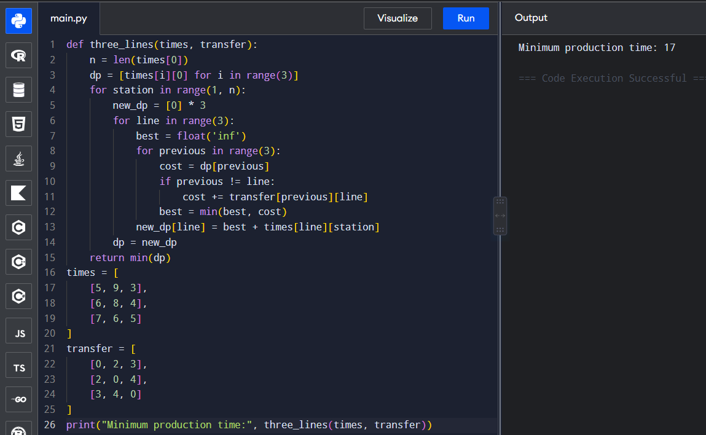
Time Complexity: O(n)
Space Complexity: O(1)

4. Write a c program to find the minimum path distance by using matrix form.
Aim
To find the minimum Hamiltonian cycle distance using a distance matrix.
Pseudo Code
- Start from city 0.
- Generate all possible permutations of the remaining cities.
- Calculate the distance of every route.
- Add the distance back to the starting city.
- Select the minimum distance.
Python Program
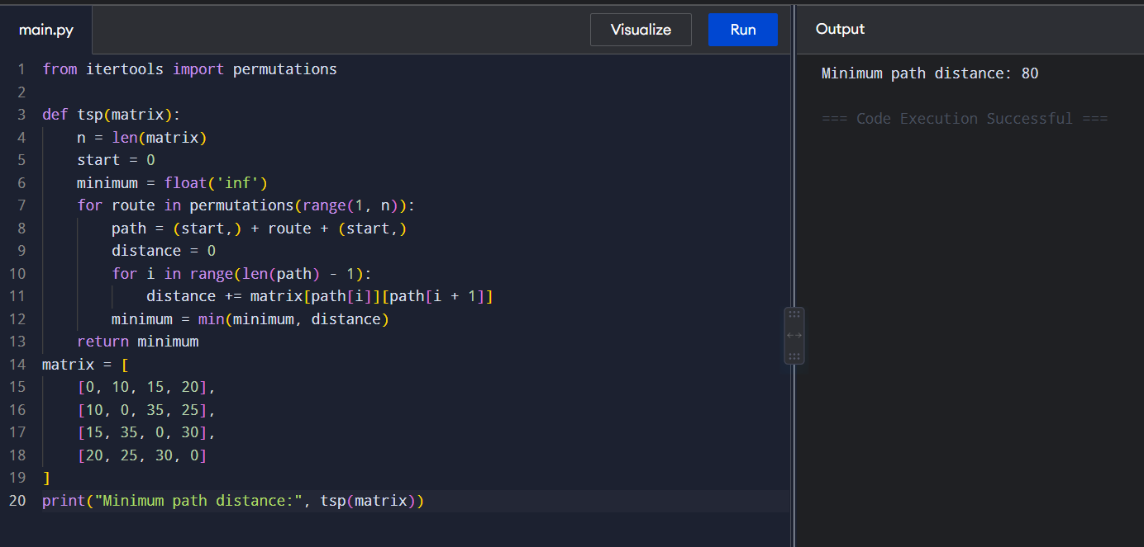
Time Complexity: O(n!)
Space Complexity: O(n)
5. Assume you are solving the Traveling Salesperson Problem for 4 cities (A, B, C, D) with known distances between each pair of cities. Now, you need to add a fifth city (E) to the problem.
Aim
To find the shortest route and total distance for five cities using exhaustive search.
Pseudo Code
- Represent cities as A, B, C, D and E.
- Start from city A.
- Generate every permutation of B, C, D and E.
- Calculate the complete route distance.
- Return to A.
- Select the route with minimum distance.
Python Program
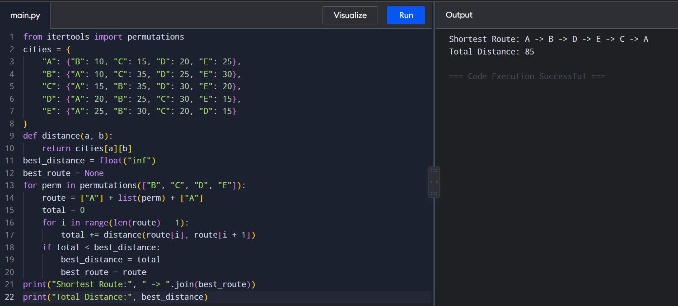
Time Complexity: O(n!)
Space Complexity: O(n)

6. Given a string s, return the longest palindromic substring in S.
Aim
To find the longest palindromic substring of a given string.
Pseudo Code
- Consider every character as the center of a palindrome.
- Expand around the center.
- Check both odd and even length palindromes.
- Keep the longest palindrome found.
- Return it.
Python Program
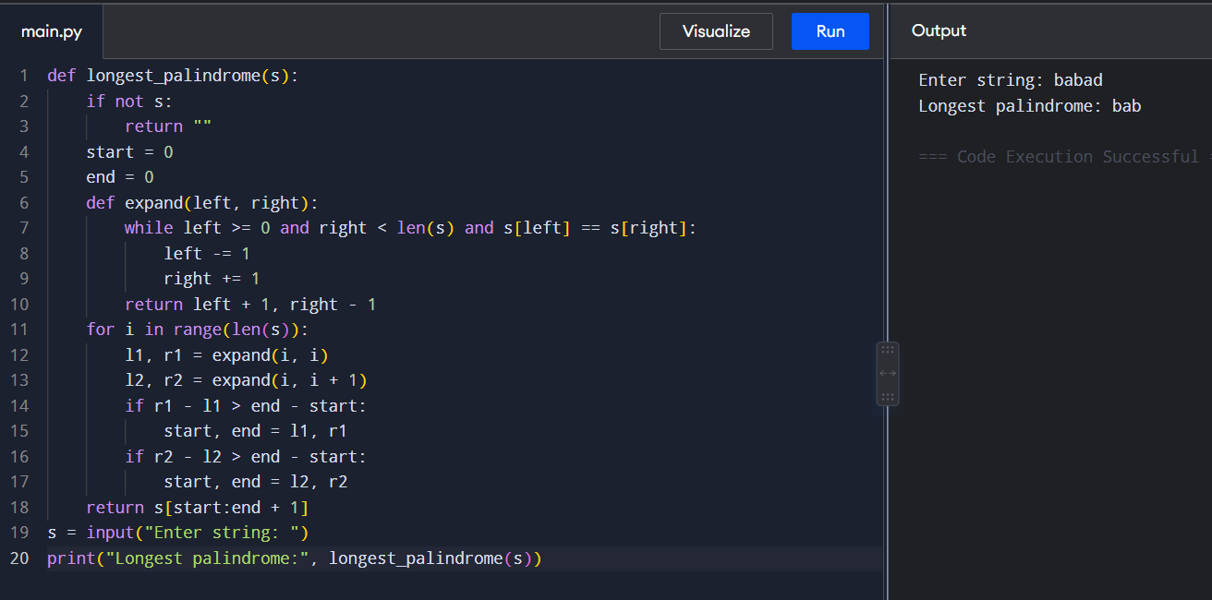
Time Complexity: O(n²)
Space Complexity: O(1)
7. Given a string s, find the length of the longest substring without repeating characters.
Aim
To find the length of the longest substring without repeating characters.
Pseudo Code
- Use two pointers left and right.
- Store the latest index of every character.
- If a character repeats inside the current window, move left.
- Calculate the current window length.
- Keep the maximum length.
Python Program
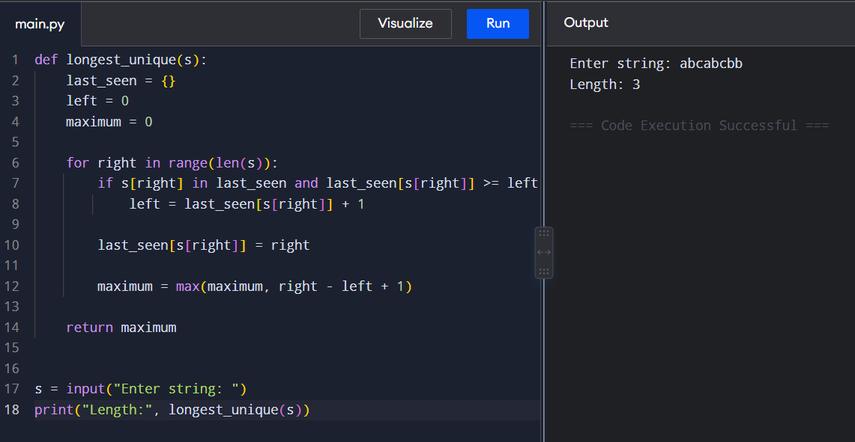
Time Complexity: O(n)
Space Complexity: O(n)
8. Given a string s and a dictionary of strings wordDict, return true if s can be segmented into a space-separated sequence of one or more dictionary words. Note that the same word in the dictionary may be reused multiple times in the segmentation.
Aim
To determine whether a string can be segmented into dictionary words.
Pseudo Code
- Create dp where dp[i] represents whether the first i characters can be segmented.
- Set dp[0] = True.
- For every position:
  - Check every dictionary word.
  - If the word ends at the current position and its previous position is reachable, mark it true.
- Return dp[n].
Python Program
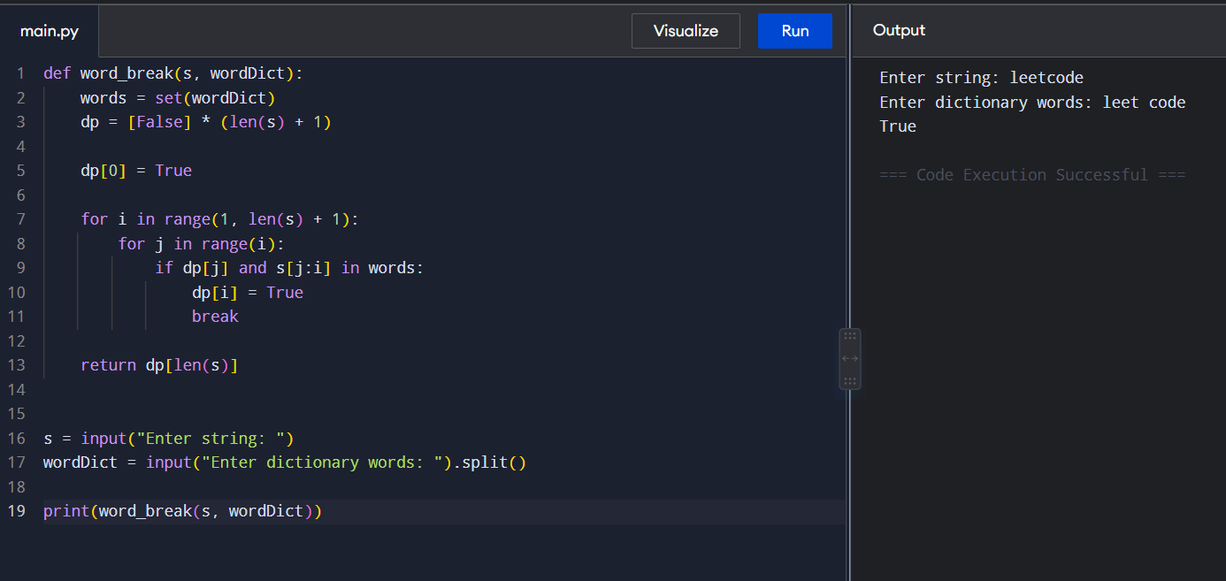
Time Complexity: O(n²)
Space Complexity: O(n)
9. Given an input string and a dictionary of words, find out if the input string can be segmented into a space-separated sequence of dictionary words. Consider the following dictionary { i, like, sam, sung, samsung, mobile, ice, cream, icecream, man, go, mango}
Aim
To determine whether the input string can be segmented using the given dictionary.
Pseudo Code
- Store all dictionary words in a set.
- Create a DP array.
- Set the empty string as reachable.
- Check every possible substring.
- If the substring is in the dictionary and the previous portion is reachable, mark the position as reachable.
- Return the final result.
Python Program
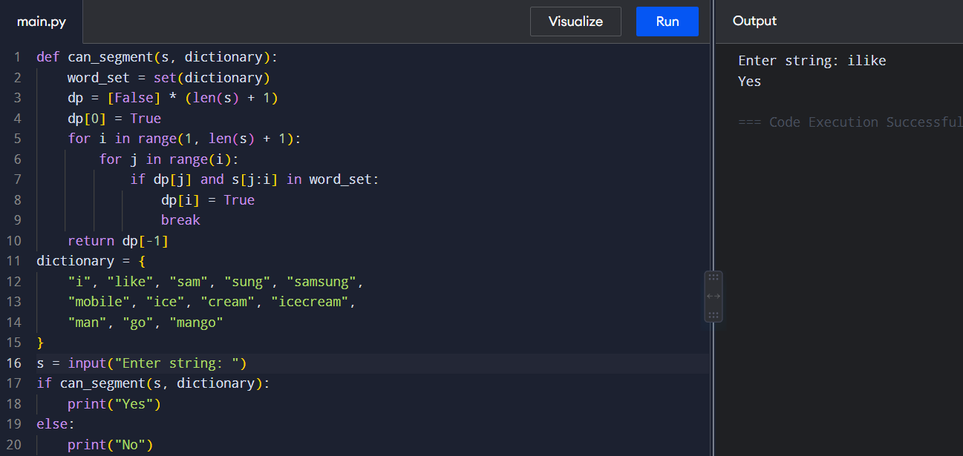
Time Complexity: O(n²)
Space Complexity: O(n)
10. Given an array of strings words and a width maxWidth, format the text such that each line has exactly maxWidth characters and is fully (left and right) justified. You should pack your words in a greedy approach; that is, pack as many words as you can in each line. Pad extra spaces ' ' when necessary so that each line has exactly maxWidth characters. Extra spaces between words should be distributed as evenly as possible. If the number of spaces on a line does not divide evenly between words, the empty slots on the left will be assigned more spaces than the slots on the right. For the last line of text, it should be left-justified, and no extra space is inserted between words. A word is defined as a character sequence consisting of non-space characters only. Each word's length is guaranteed to be greater than 0 and not exceed maxWidth. The input array words contains at least one word.
Aim
To format a given list of words so that every line contains exactly maxWidth characters and is fully justified.
Pseudo Code
- Select as many words as possible for the current line.
- Calculate the number of spaces required.
- If it is the last line or contains one word:
  - Left justify the line.
- Otherwise:
  - Distribute spaces evenly between words.
  - Give extra spaces to the leftmost gaps.
- Repeat until all words are processed.
Python Program
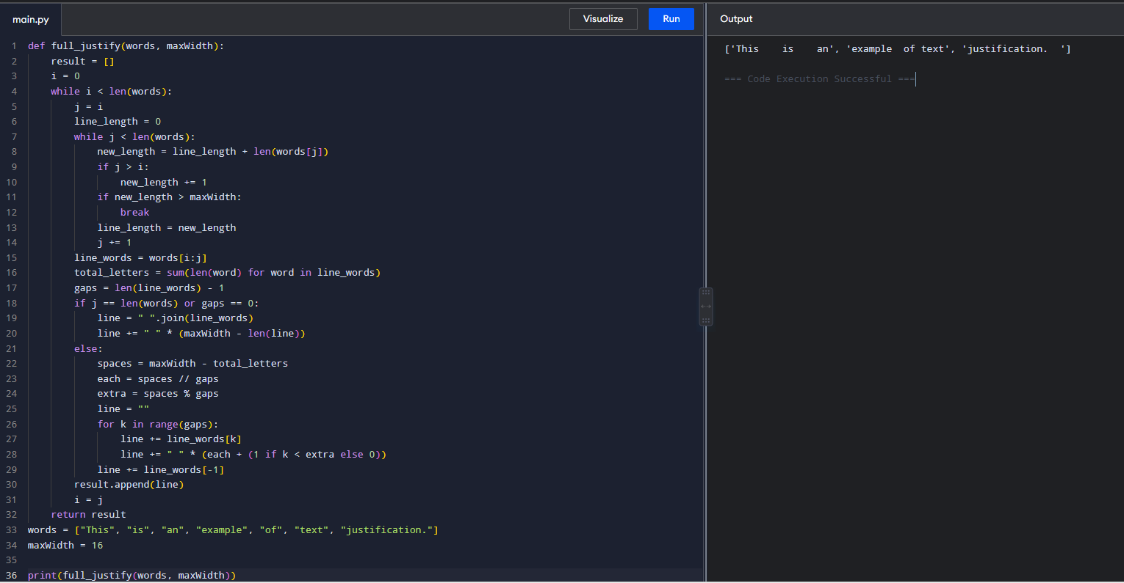
Time Complexity: O(n)
Space Complexity: O(n)
11. Design a special dictionary that searches the words in it by a prefix and a suffix. Implement the WordFilter class: WordFilter(string[] words) Initializes the object with the words in the dictionary.f(string pref, string suff) Returns the index of the word in the dictionary, which has the prefix pref and the suffix suff. If there is more than one valid index, return the largest of them. If there is no such word in the dictionary, return -1.
Aim
To design a special dictionary that finds the largest index of a word having the given prefix and suffix.
Pseudo Code
- Store all words with their indices.
- For every word, generate all possible prefix-suffix combinations.
- Store the index for each combination.
- When f(prefix, suffix) is called, form the key prefix#suffix.
- Return the stored largest index.
- Return -1 if the key does not exist.
Python Program
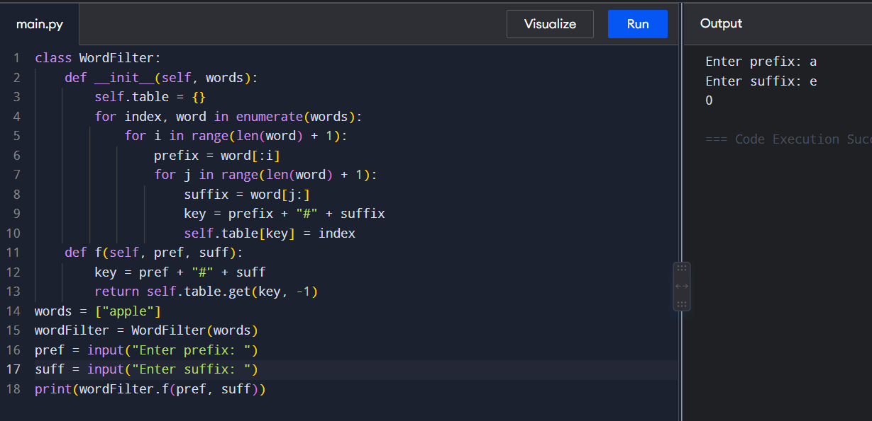
Time Complexity: O(n × L²)
Space Complexity: O(n × L²)
12. Implement Floyd's Algorithm to find the shortest path between all pairs of cities. Display the distance matrix before and after applying the algorithm. Identify and print the shortest path
AIM
To find the shortest paths between all pairs of cities using Floyd's Algorithm.
ALGORITHM
- Initialize the distance matrix using the given edge distances.
- Set the distance from a city to itself as 0.
- Select each city as an intermediate city.
- Update the distance using dist[i][j] = min(dist[i][j], dist[i][k] + dist[k][j]).
- Repeat until all cities are considered.
- Display the final shortest-distance matrix.
- Find the required shortest path.
PYTHON PROGRAM
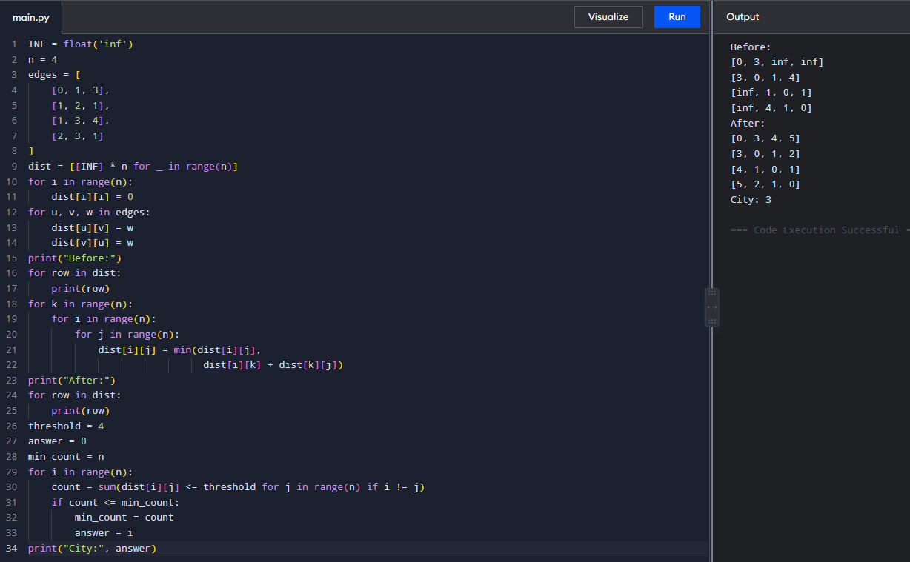
TIME COMPLEXITY: O(n³)
SPACE COMPLEXITY: O(n²)

13. Write a Program to implement Floyd's Algorithm to calculate the shortest paths between all pairs of routers. Simulate a change where the link between Router B and Router D fails. Update the distance matrix accordingly. Display the shortest path from Router A to Router F before and after the link failure.

AIM
To find the shortest path between all routers using Floyd's Algorithm and compare the path before and after a link failure.
ALGORITHM
- Initialize the distance matrix with the given router links.
- Set diagonal elements to 0.
- Apply Floyd's Algorithm to find all-pairs shortest paths.
- Find the shortest path from Router A to Router F.
- Remove the link between Router B and Router D.
- Apply Floyd's Algorithm again.
- Display the shortest path before and after failure.
PYTHON PROGRAM
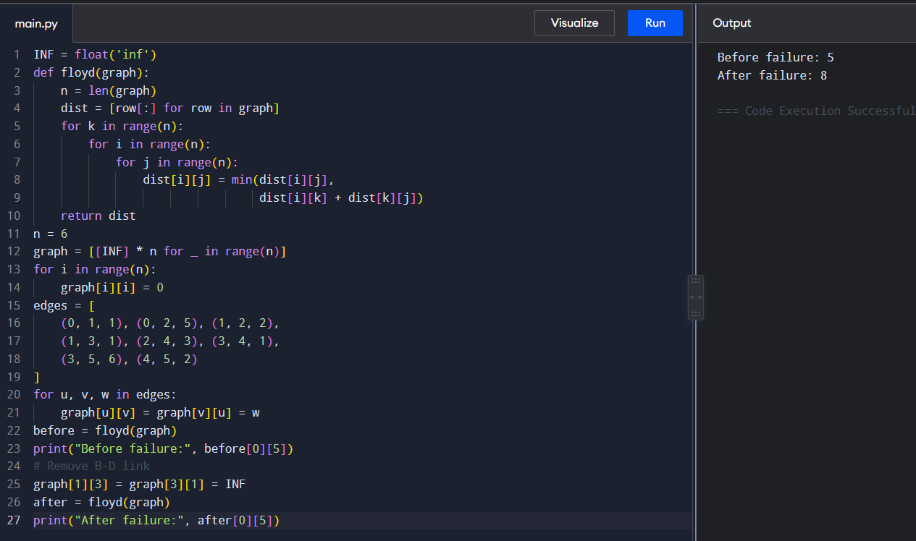
TIME COMPLEXITY: O(n³)
SPACE COMPLEXITY: O(n²)
14. Implement Floyd's Algorithm to find the shortest path between all pairs of cities. Display the distance matrix before and after applying the algorithm. Identify and print the shortest path
AIM
To find the shortest paths between all pairs of cities using Floyd's Algorithm.
ALGORITHM
- Create a distance matrix using the given edges.
- Set the distance from every city to itself as 0.
- Select each city as an intermediate city.
- Update the shortest distance through the intermediate city.
- Repeat for all intermediate cities.
- Display the final distance matrix.
- Find the required shortest path.
PYTHON PROGRAM
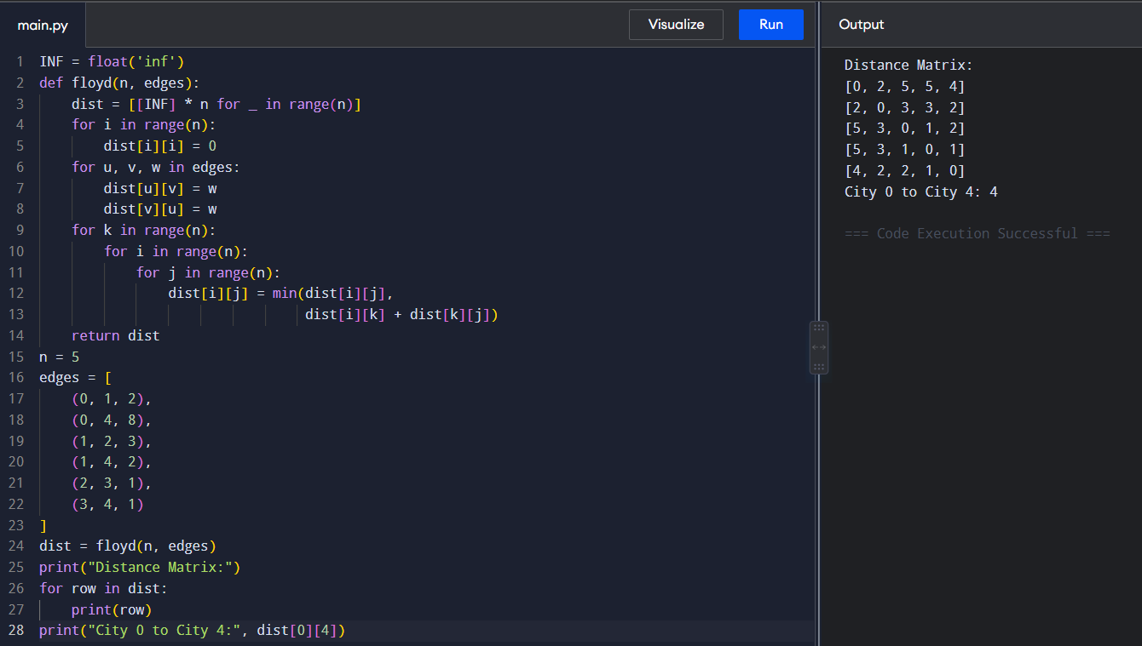
TIME COMPLEXITY: O(n³)
SPACE COMPLEXITY: O(n²)
15. Implement the Optimal Binary Search Tree algorithm for the keys A,B,C,D with frequencies 0.1,0.2,0.4,0.3 Write the code using any programming language to construct the OBST for the given keys and frequencies. Execute your code and display the resulting OBST and its cost. Print the cost and root matrix.
AIM
To construct an Optimal Binary Search Tree with minimum search cost.
ALGORITHM
- Store the frequencies of all keys.
- Create a cost table for different key ranges.
- For every range, calculate its total frequency.
- Try each key as the root.
- Calculate the cost of left and right subtrees.
- Select the root having minimum cost.
- Store the minimum cost and root.
- Display the cost and root tables.
PYTHON PROGRAM
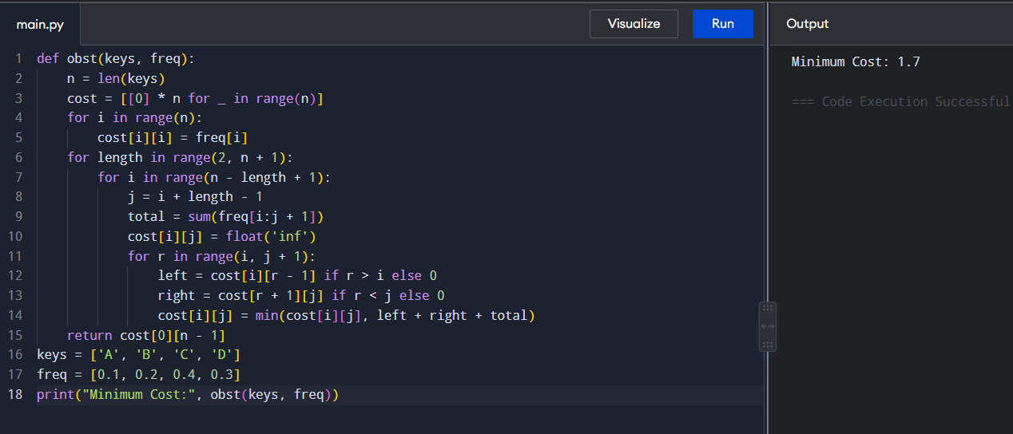
TIME COMPLEXITY: O(n³)
SPACE COMPLEXITY: O(n²)
16. Consider a set of keys 10,12,16,21 with frequencies 4,2,6,3 and the respective probabilities. Write a Program to construct an OBST in a programming language of your choice. Execute your code and display the resulting OBST, its cost and root matrix.
AIM
To construct an Optimal Binary Search Tree for the given keys and frequencies.
ALGORITHM
- Initialize the cost table using individual key frequencies.
- Consider increasing lengths of key ranges.
- Calculate the total frequency of each range.
- Try every key as the root.
- Calculate the left and right subtree costs.
- Choose the minimum cost.
- Store the corresponding root.
- Display the minimum cost and root matrix.
PYTHON PROGRAM
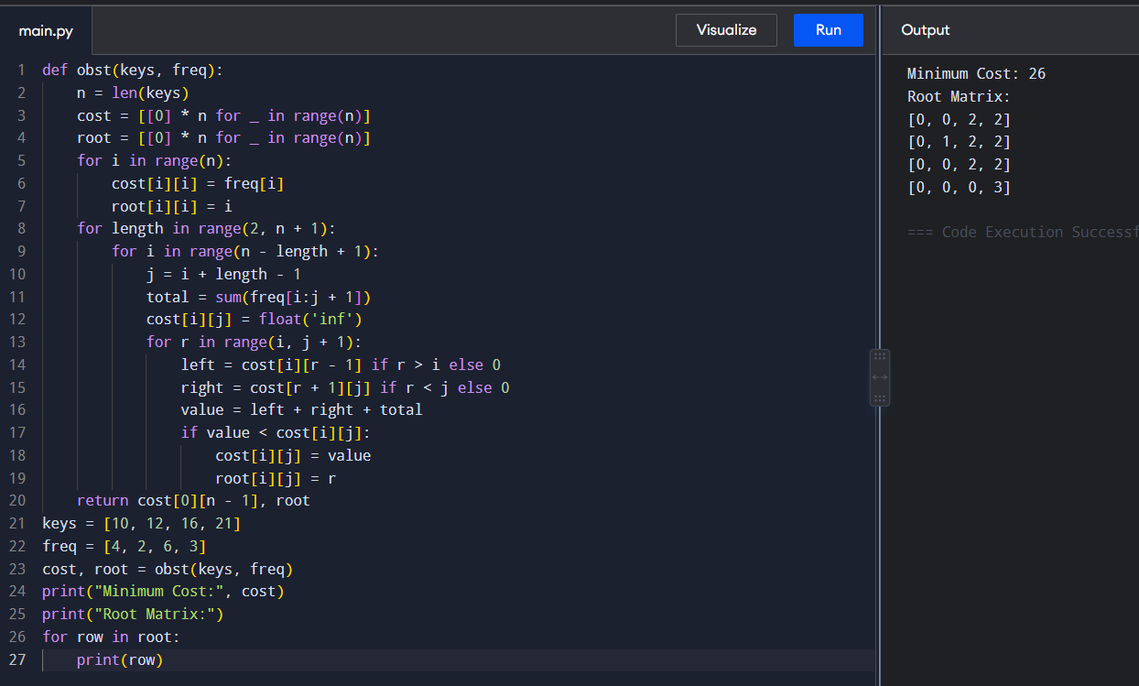
TIME COMPLEXITY: O(n³)
SPACE COMPLEXITY: O(n²)
17. A game on an undirected graph is played by two players, Mouse and Cat, who alternate turns. The graph is given as follows: graph[a] is a list of all nodes b such that ab is an edge of the graph. The mouse starts at node 1 and goes first, the cat starts at node 2 and goes second, and there is a hole at node 0. During each player's turn, they must travel along one edge of the graph that meets where they are. For example, if the Mouse is at node 1, it must travel to any node in graph[1]. Additionally, it is not allowed for the Cat to travel to the Hole (node 0).Then, the game can end in three ways:
AIM
To determine whether Mouse wins, Cat wins, or the game ends in a draw when both players play optimally.
ALGORITHM
- Represent each state as (mouse, cat, turn).
- Mouse wins if it reaches node 0.
- Cat wins if it reaches the mouse.
- Generate all possible moves for the current player.
- Use dynamic programming to determine winning and losing states.
- Repeat until all relevant states are determined.
- Return 1 for Mouse, 2 for Cat, or 0 for Draw.
PYTHON PROGRAM
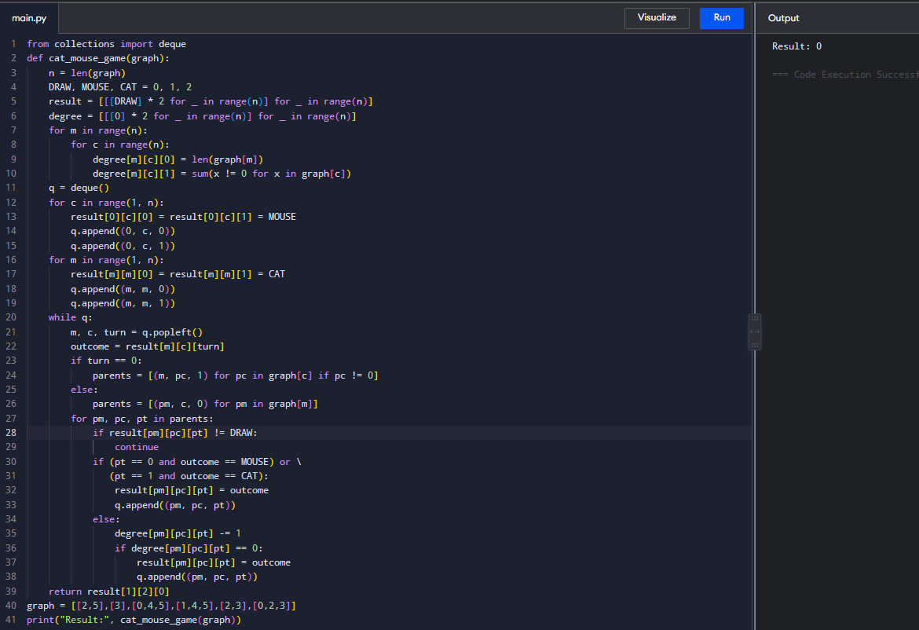
TIME COMPLEXITY: O(n³)
SPACE COMPLEXITY: O(n²)
18. You are given an undirected weighted graph of n nodes (0-indexed), represented by an edge list where edges[i] = [a, b] is an undirected edge connecting the nodes a and b with a probability of success of traversing that edge succProb[i]. Given two nodes start and end, find the path with the maximum probability of success to go from start to end and return its success probability. If there is no path from start to end, return 0. Your answer will be accepted if it differs from the correct answer by at most 1e-5.
AIM
To find the path with the maximum probability of success between two nodes.
ALGORITHM
- Create an adjacency list containing neighboring nodes and probabilities.
- Set the probability of the starting node to 1.
- Select the node with the highest current probability.
- Update the probabilities of its neighboring nodes.
- Continue until the destination is reached.
- Return the maximum probability.
PYTHON PROGRAM
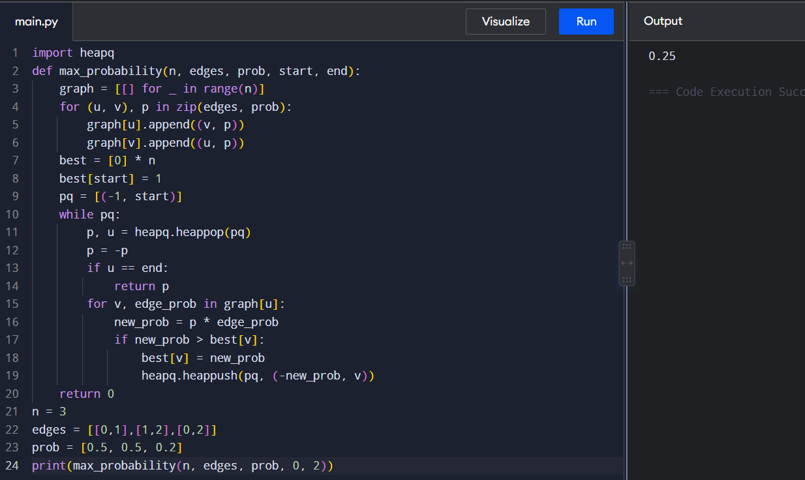
TIME COMPLEXITY: O((V + E) log V)
SPACE COMPLEXITY: O(V + E)

19. There is a robot on an m x n grid. The robot is initially located at the top-left corner (i.e., grid[0][0]). The robot tries to move to the bottom-right corner (i.e., grid[m - 1][n - 1]). The robot can only move either down or right at any point in time. Given the two integers m and n, return the number of possible unique paths that the robot can take to reach the bottom-right corner. The test cases are generated so that the answer will be less than or equal to 2 * 10 9.
AIM
To find the number of unique paths from the top-left to the bottom-right corner of a grid.
ALGORITHM
- Create a DP array for the columns.
- Initialize all positions to 1.
- For each row, update each position as the sum of the top and left paths.
- Continue until the last cell.
- Return the value at the bottom-right cell.
PYTHON PROGRAM
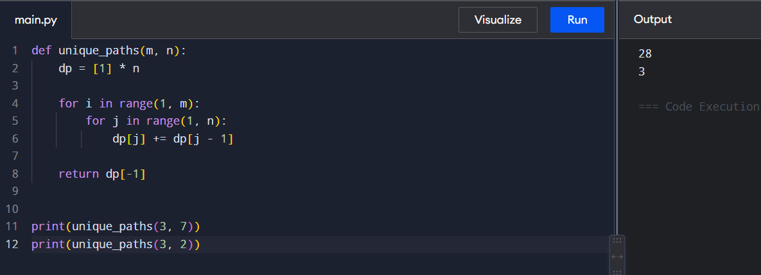
TIME COMPLEXITY: O(m × n)
SPACE COMPLEXITY: O(n)

20. Given an array of integers nums, return the number of good pairs. A pair (i, j) is called good if nums[i] == nums[j] and i < j.
AIM
To count the number of pairs (i, j) where nums[i] == nums[j] and i < j.
ALGORITHM
- Create a frequency dictionary.
- Traverse the array from left to right.
- For each number, add its previous frequency to the answer.
- Increase its frequency by 1.
- Return the total number of pairs.
PYTHON PROGRAM
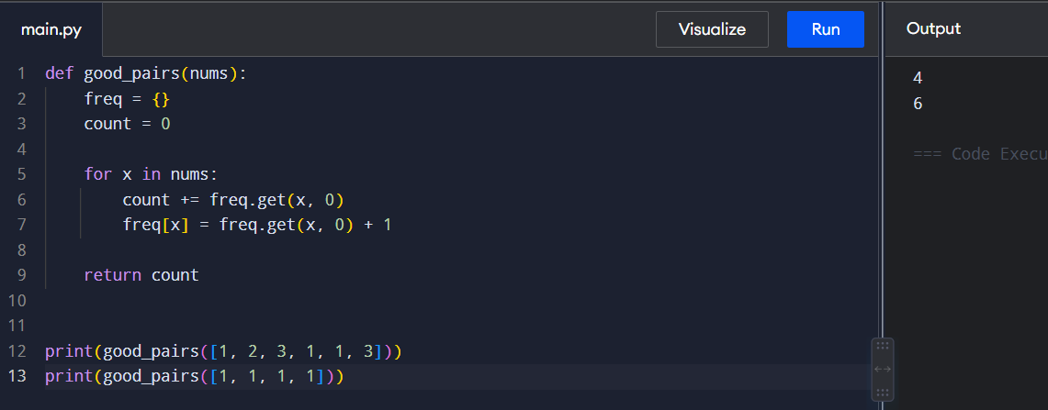
TIME COMPLEXITY: O(n)
SPACE COMPLEXITY: O(n)

21. There are n cities numbered from 0 to n-1. Given the array edges where edges[i] = [fromi, toi, weighti] represents a bidirectional and weighted edge between cities fromi and toi, and given the integer distance Threshold. Return the city with the smallest number of cities that are reachable through some path and whose distance is at most distanceThreshold, If there are multiple such cities, return the city with the greatest number. Notice that the distance of a path connecting cities i and j is equal to the sum of the edges' weights along that path.
AIM
To find the city having the smallest number of reachable cities within the given distance threshold.
ALGORITHM
- Initialize the distance matrix.
- Set diagonal distances to 0.
- Insert all edge weights into the matrix.
- Apply Floyd's Algorithm.
- Count cities reachable within the threshold for every city.
- Select the city with the smallest count.
- If counts are equal, select the city with the greatest index.
PYTHON PROGRAM
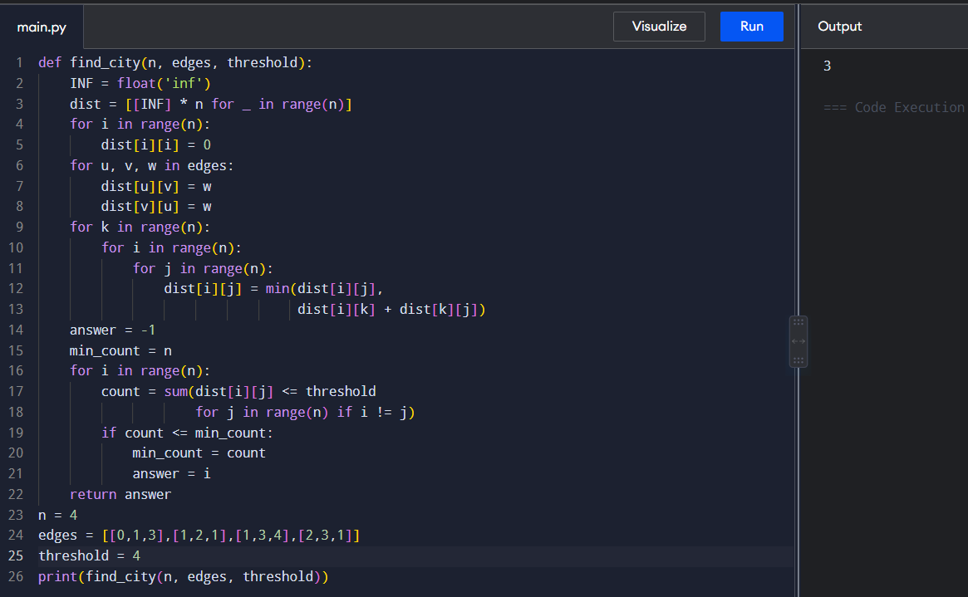
TIME COMPLEXITY: O(n³)
SPACE COMPLEXITY: O(n²)
22. You are given a network of n nodes, labeled from 1 to n. You are also given times, a list of travel times as directed edges times[i] = (ui, vi, wi), where ui is the source node, vi is the target node, and wi is the time it takes for a signal to travel from source to target. We will send a signal from a given node k. Return the minimum time it takes for all the n nodes to receive the signal. If it is impossible for all the n nodes to receive the signal, return -1.
AIM
To find the minimum time required for a signal to reach all nodes using Dijkstra's Algorithm.
ALGORITHM
- Create an adjacency list for the directed graph.
- Set the distance of the source node to 0.
- Insert the source into a priority queue.
- Select the node having the smallest distance.
- Update the distances of its neighboring nodes.
- Continue until the priority queue becomes empty.
- Find the maximum shortest distance.
- If any node is unreachable, return -1.
PYTHON PROGRAM
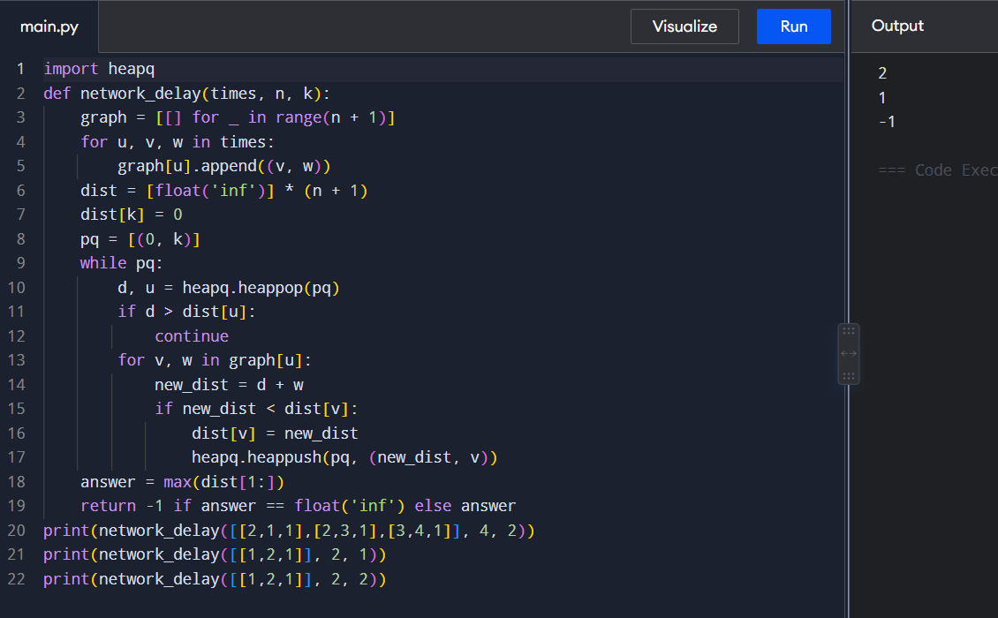
TIME COMPLEXITY: O((V + E) log V)
SPACE COMPLEXITY: O(V + E)

